eBlessings International Daily Devotional Archives
enrich, inspire, encourage, bless, and empower spiritual warriors for end-time battles
Devotionals Designed to Empower and Grow Our Spirits

JANUARY2010JANUARY2010JANUARY2010
IDD 2004 | IDD 2005 | IDD 2006 | IDD 2007 | IDD 2008 | IDD 2009 | IDD 2010
Visit DOT, and WOW Empowerment Series, plus Prophecy, Spiritual Keys & Lessons, IA, PP and more...

Each One! Bless One!
You Make a Difference!

* * * * *

Pencils… all pencils. Beautiful... There is art in everything... You just have to have the eye for it...

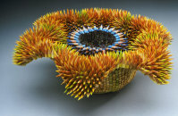 | 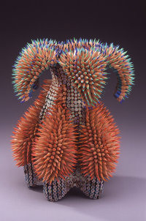 | 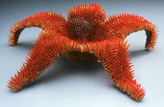
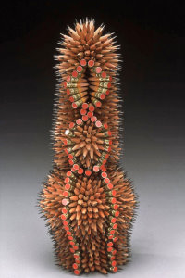 | 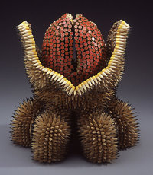 | 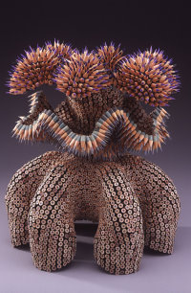
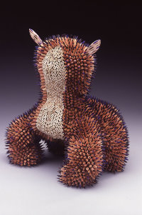 | 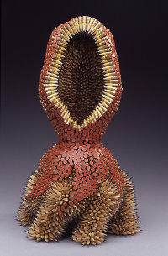 | 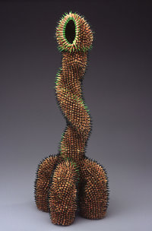

Don't use time carelessly — it can never be retrieved! Life is precious!!
Try not to waste neither your time nor your resources.

InternetANGEL
See “K” Under Oddities
Thanks Lana

