eBlessings International Daily Devotional Archives
enrich, inspire, encourage, bless, and empower spiritual warriors for end-time battles
prepared with the guidance of the Holy Spirit for spiritual growth and victory!
Devotionals Designed to Empower and Grow Our Spirits

SEPTEMBER2008SEPTEMBER2008SEPTEMBER2008
Visit DOT, and WOW Empowerment Series,
plus Prophecy, Spiritual Keys & Lessons, IA, PP and more...

Each One! Bless One!
You Make a Difference!

* * * * *

EXCERPT FROM IJAC?: IS JESUS A CRACKHEAD? (continued)

CHAPTER
16
(PART TWO)

My focus was on the Hierarchy and lowerarchy because the word “principalities” stood out in the Ephesians passage; and in an effort to place the entity in a power hierarchy, I searched for hierarchies in the Bible. I then asked my pastor what the principalities of God were. The answer was: “We are the principalities of God.” I didn’t buy that one. I could tell the question caught him off guard and the Holy Spirit in me did not bear witness to his answer.

I asked another pastor the question and he told me: “God does not have principalities. Principalities are evil.” My spirit bore witness to him on that but I knew in my spirit that God would have something at least equal to evil principalities.

Arch-Angels are not equal to principalities; nor are Angels—then what was, I asked the Holy Spirit? One night as I was reading my Bible, I read:

“But the fruit of the Spirit is love, joy, peace, longsuffering, kindness, goodness, faithfulness, gentleness, self-control. Against such there is no law.”
Galatians 5:22-23 (NKJV)

When I finished reading this scripture, it was as though I hadn’t read it. So I read it again, because I knew in my heart, (my spiritual heart, not to be confused with emotions or feelings) that I had missed something. I have learned, when I am reading something or doing something and I do not remember reading it or doing it, that the Holy Spirit or an Angel is with me, illuminating me to see something specific or to do something specific, that I didn’t see or do the first time. I have learned to ask them to let me see the spiritual or do the spiritual through “spiritual” eyes (vision) or “spiritual” feet (direction). So I read it again.

This time as I read it, the Holy Spirit let me see in my mind’s eye an apple tree. In my spirit, I knew the apple tree represented the Holy Spirit. And the scripture said, “the fruit of the Spirit…,” so I knew the fruits of the Spirit were the apples on the tree. And I believe that the fruits of the Spirit are the next level down on the Heavenly Hierarchy. “Love” is one of the fruits of the Spirit. Well I know that the scripture says, “God is love.”

“He who does not love does not know God, for God is love.”
1 John 4:8 (NKJV)

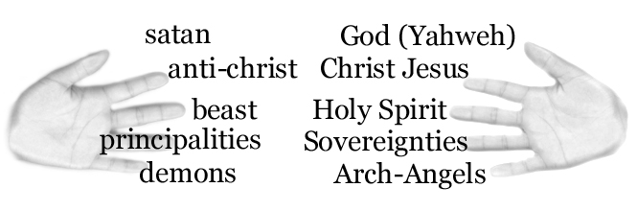
So now I equate “love” as not only a word, not only a fruit of the Spirit (Holy Spirit) being under the Holy Spirit in the Heavenly Hierarchy, but “Love” as being a powerful entity bearing the characteristics and attributes of God.

EXCERPT FROM IJAC? TO BE CONTINUED

James Anthony Allen Born-Again, Holy Ghost-filled, Tongue-speaking, Lion of Judah, Evangelist and US Patriot
http://www.eBlessings.us ; eBlessings@gmail.com
Stone Mountain, Georgia, USA, North America

