eBlessings International Daily Devotional Archives
enrich, inspire, encourage, bless, and empower spiritual warriors for end-time battles
prepared with the guidance of the Holy Spirit for spiritual growth and victory!
Devotionals Designed to Empower and Grow Our Spirits

SEPTEMBER2008SEPTEMBER2008SEPTEMBER2008
Visit DOT, and WOW Empowerment Series,
plus Prophecy, Spiritual Keys & Lessons, IA, PP and more...

Each One! Bless One!
You Make a Difference!

* * * * *

EXCERPT FROM IJAC?: IS JESUS A CRACKHEAD? (continued)

CHAPTER
16
(PART FOUR)

The question is where does man come into the picture? Where does man fit into the Heavenly Hierarchy? People say, we are a little lower than Angels or we are just above the Angels. What does the Bible say?

“For thou hast made him a little lower than angels, and hast crowned him with glory and honour.”
Psalm 8:5

This is what satan would have you believe and to hold on to. Give me a minute here and I will break it down for you. Stay with me. Where does satan belong in the evil hierarchy (lowerarchy)? You say at the top—opposite God? Right? WRONG! That is a big WRONG!

What was satan when he was in Heaven? He was an Arch-Angel. Where do Arch-Angels rank? Below fruits of the Spirit; Sovereignties and Authorities. Okay, so now you know that he is not equal to God on the hierarchy playing field. His whole hierarchy (lowerarchy) scale is to be shifted down in our hearts and minds.

Now, let me ask you again. Where does man fit into this equation? A little lower than Angels is for those members of mankind who do not believe and serve God through Jesus Christ. For believers, the Bible says:

“Behold, what manner of love the Father hath bestowed upon us, that we should be called the sons of God: therefore the world knoweth us not, because it knew him not.”
1 John 3:1

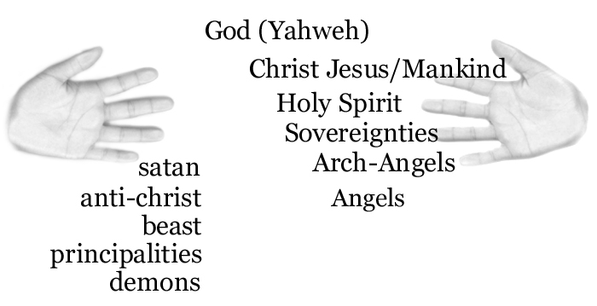
We are the sons and daughters of the Lord God Almighty. (Romans 8:19; Galatians 4:6; Philemon 2:15; 1 John 3:2) Jesus is our brother. God is our Father. When we are not saved, we are a little lower than the Angels. But when we are saved, then we are above the Arch-Angels and on the same level as Jesus, being children of God.

Now you see why I said remember this. Satan wants us to think that he is all-powerful and has dominion over us. He does not. He is our footstool. (Psalm 110:1; Matthew 22:44) We are above him in the hierarchy of God’s Creation. We have to remember that and walk with that. Live with that knowledge in your heart.

END OF EXCERPT FROM IJAC?


James Anthony Allen Born-Again, Holy Ghost-filled, Tongue-speaking, Lion of Judah, Evangelist and US Patriot
http://www.eBlessings.us ; eBlessings@gmail.com
Stone Mountain, Georgia, USA, North America

